# WEAKER WORDING

# RELIGIOUS ACCOMMODATION REQUEST FORM

Individual’s Name Requesting Exemption (Requestor):

Date of Request: Telephone Number:

Email Address:

Requestor's Position: Duty Location:

1. Please specifically identify the organization’s requirements, policy, or practice that conflicts with your beliefs.
2. Please describe in detail the nature of your sincerely held religious beliefs, religious practice or observance that conflict with the organization’s requirements, policy, or practice.
3. What is the accommodation or modification that you are requesting?
4. List any alternative accommodations that also would eliminate the conflict between the EEOC requirement, policy, or practice and your sincerely held religious beliefs.

“I assert that all of the information I am providing is true and accurate. If not, I understand that disciplinary action may result, up to and including termination.”

Individual’s Signature: _______________________________________________________

Date

**ORGANIZATION’S INVESTIGATION REPORT: FOR INTERNAL USE ONLY**

1. Has the individual acted in a manner inconsistent with their professed belief?

(NOTE: Individual employees need not be scrupulous in their observance.) Attach and examples as needed.

1. If an alternative accommodation was offered, indicate whether it was:

___ Accepted ___ Not Accepted

1. Were any accommodations offered and rejected? If so, state the basis for rejection.
2. If the accommodation is denied and no alternative accommodation was proposed, explain the basis for denying the request without an alternative accommodation. Attach any supporting evidence.

Organization Official (Print Name): ________________________________________________

Date

Organization Official Signature: ________________________________________________

Date

For first-hand EEOC guidance, please hit this hotlink: <https://www.eeoc.gov/wysk/what-you-should-know-about-covid-19-and-ada-rehabilitation-act-and-other-eeo-laws?utm_content=&utm_medium=email&utm_name=&utm_source=govdelivery&utm_term=>

***Scott Warrick, Esq.***

***Scott Warrick Human Resource Consulting & Employment Law Services***

**1147 Matterhorn Drive, Reynoldsburg, Ohio 43068**

**(614) 738-8317 ♣** [**scott@scottwarrick.com**](mailto:scott@scottwarrick.com)[**WWW.SCOTTWARRICK.COM**](http://www.scottwarrick.com/)   
**Link Up With Scott On** [**LinkedIn**](http://www.linkedin.com/in/scottwarrickconsulting)

Scott Warrick, JD, MLHR, CEQC, SHRM-SCP ([www.scottwarrick.com](http://www.scottwarrick.com)) is both a practicing Employment Law Attorney and Human Resource Professional with 40 years of hands-on experience.

Scott combines the areas of law and human resources to help organizations in “Solving Employee Problems ***BEFORE*** They Start.” Scott’s goal is ***NOT*** to win lawsuits. Instead, Scott’s goal is to ***PREVENT THEM*** while improving ***EMPLOYEE MORALE***.

Scott is also a best-selling author. His first book, [***Solve Employee Problems Before They Start: Resolving Conflict in the Real World***](https://scottwarrick.com/), is a #1 Best Seller for Business and Conflict Resolution. It was also named by EGLOBALIS as one of the best global Customer and Employee books for 2020-2021. Scott’s most recent book, [***Living The Five Skills of Tolerance***](https://scottwarrick.com/tolerance-and-diversity-for-white-guys/)***: A User’s Manual For Today’s World***, is also a #1 Best Seller in 13 categories, including Business Leadership, Educational Leadership, Minority Studies, Organizational Change, Religious Intolerance and Race Relations.

Scott’s [***MASTER HR TOOL KIT SUBSCRIPTION***](https://scottwarrick.com/products/hr-toolkit/)is a favorite for anyone wanting to learn Employment Law and run an HR Department.

Scott has been named one of Business First’s 20 People To Know In HR, CEO Magazine’s 2008 Human Resources “Superstar,” a Nationally Certified Emotional Quotient Counsellor (CEQC) and a SHRM National Diversity Conference Presenter in 2003, 2006, 2007, 2008 and 2012. Scott has also received the Human Resource Association of Central Ohio’s Linda Kerns Award for Outstanding Creativity in the Field of HR Management and the Ohio State Human Resource Council’s David Prize for Creativity in HR Management.

Scott’s academic background and awards include Capital University College of Law (Class Valedictorian (1st out of 233) and Summa Cum Laude), Master of Labor & Human Resources and B.A. in Organizational Communication from The Ohio State University.

**For more information on Scott, just go to** [**www.scottwarrick.com**](http://www.scottwarrick.com).

[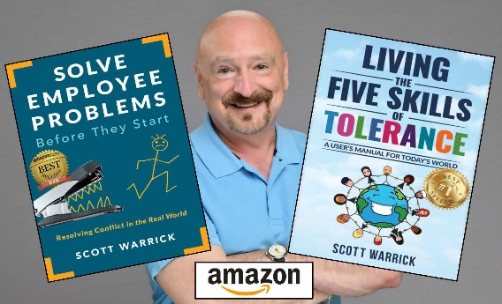](https://scottwarrick.com/living-the-five-skills-of-tolerance/)