THE CLERGY

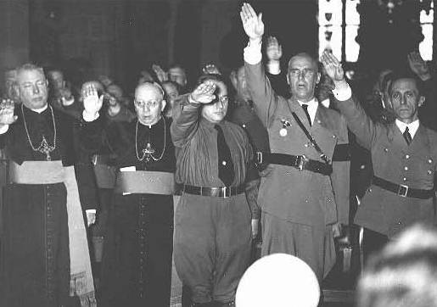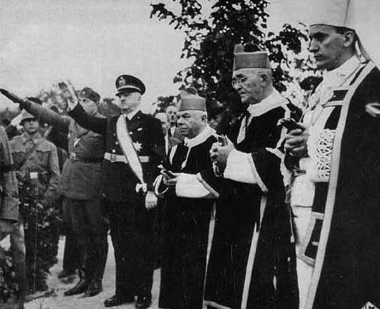
Catholic priests and ministers who opposed the Nazis were arrested and sent to Dachau, which imprisoned more members of the clergy than any other concentration camp. At Dachau, they endured the worst persecution of the Christian clergy in modern history. Dachau had a special "priest block" with over 2,700 prisoners from at least 20 different nations. One out of every three would not survive.
- When you look at the faces of the clergy in these photos, what do you see?

- If you look at the photo on the left, the priests’ salutes are not as strong and forceful as the Nazis standing to their right.
- Why do you suppose that is?

- Both priests in the far left photo also have a dazed look about them. What do you think is going through their minds?

- Is merely giving the Nazi salute complicity?

- If you look at the photo on the right, the priests are not saluting at all.
- What kind of risk are they taking by not saluting? Is this wise?

- Look at the faces of the priests in the far right photo. What is their dilemma?

- What would YOU have done? Would you have saluted, even begrudgingly, like the clergy in the left photo, or would you have refused, like the clergy in the photo on the right?

- What price would you pay either way?

