CLOSING THOUGHTS ON EMPATHY:
DISCUSSION QUESTIONS

- How have you seen “Eugenics,” or “Social Engineering,” used in our own history? (i.e., segregation laws, euthanasia, sterilization, marriage bans, genocide, etc.) How do you feel about that?

- Do you ever refer to others as, “All those people?” Does that make us feel better about ourselves by putting others down and “objectifying” them, which is to see others as being less than human?

- Are you as likely to objectify others and minimize their needs if you have a heightened ability to empathize with others? Why … or why not?

- Who was to blame for the Holocaust? (Do you speak up when you see “wrong-doing?”)

WHO IS TO BLAME?

EVERYONE WHO STOOD BY AND DID NOTHING.

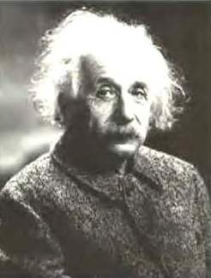

“The world is a dangerous place to live not because of the people who are evil,
but because of the people who don't do anything about it.”
~~ Albert Einstein

What Is Evil?
To Do Nothing Is To Cooperate With Oppression.
EVIL = PASSIVITY

What Do YOU Do When You See Evil? To Stand By And Do NOTHING Is Evil.
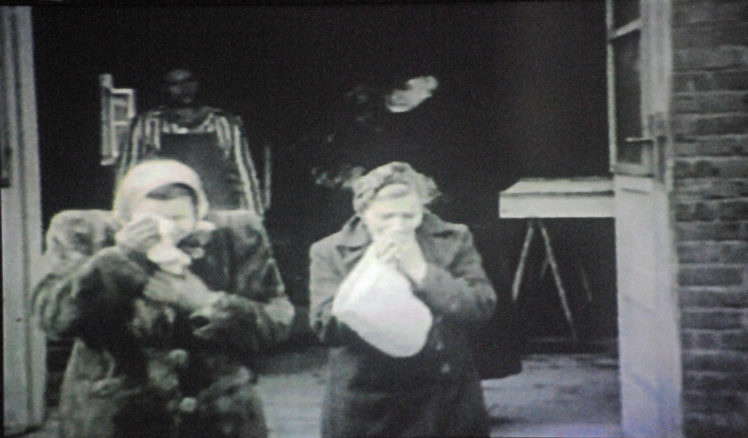
Dachau villagers forced to tour the camp to see what they did.

