COTTON BOLLS
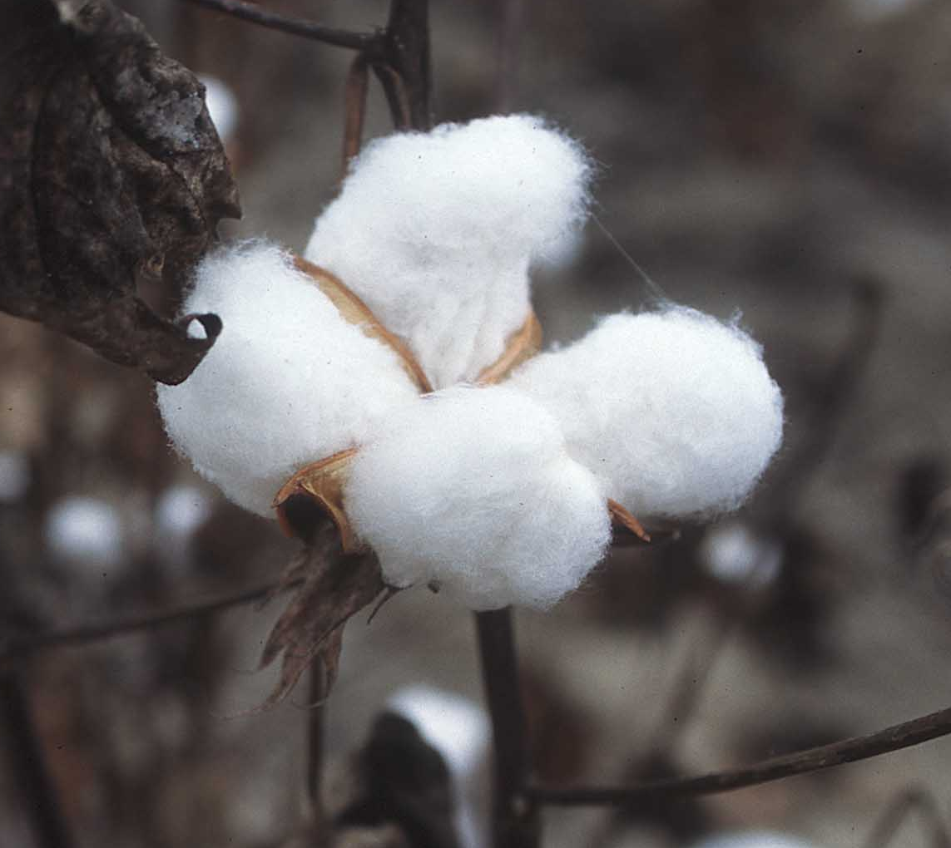
To be a slave in America meant you would not have any “say” over your own life. Self-determination was not possible. It might also mean that you would most likely be separated from your wife, children, parents, siblings and so on without ever seeing them again. In short, it was a demeaning existence.
It also meant hours of back-breaking work. You would spend most of your life out in the fields picking cotton bolls for your master, never realizing the fruits of your own labor.
At first, picking cotton does not sounds all that bad. When we think of cotton, we think of something nice and soft that feels pleasant in your hands. However, that was not the case at all.
While cotton bolls are soft in the middle, they are surrounded by razor sharp edges from the shell that has cracked open. As the slave picked the cotton boll from the stem, their fingers would be cut to pieces. Over the years, their fingers would be more covered in more scar tissue than skin.
A very powerful empathy exercise is to have your students or attendees feel a real cotton boll. Let them feel the soft center and the horrendously sharp edges. This is an experience they will never forget.
To obtain real cotton bolls for your class, just do an internet search for “cotton bolls” and youi will find plenty to order.

