CROWN OF THORNS
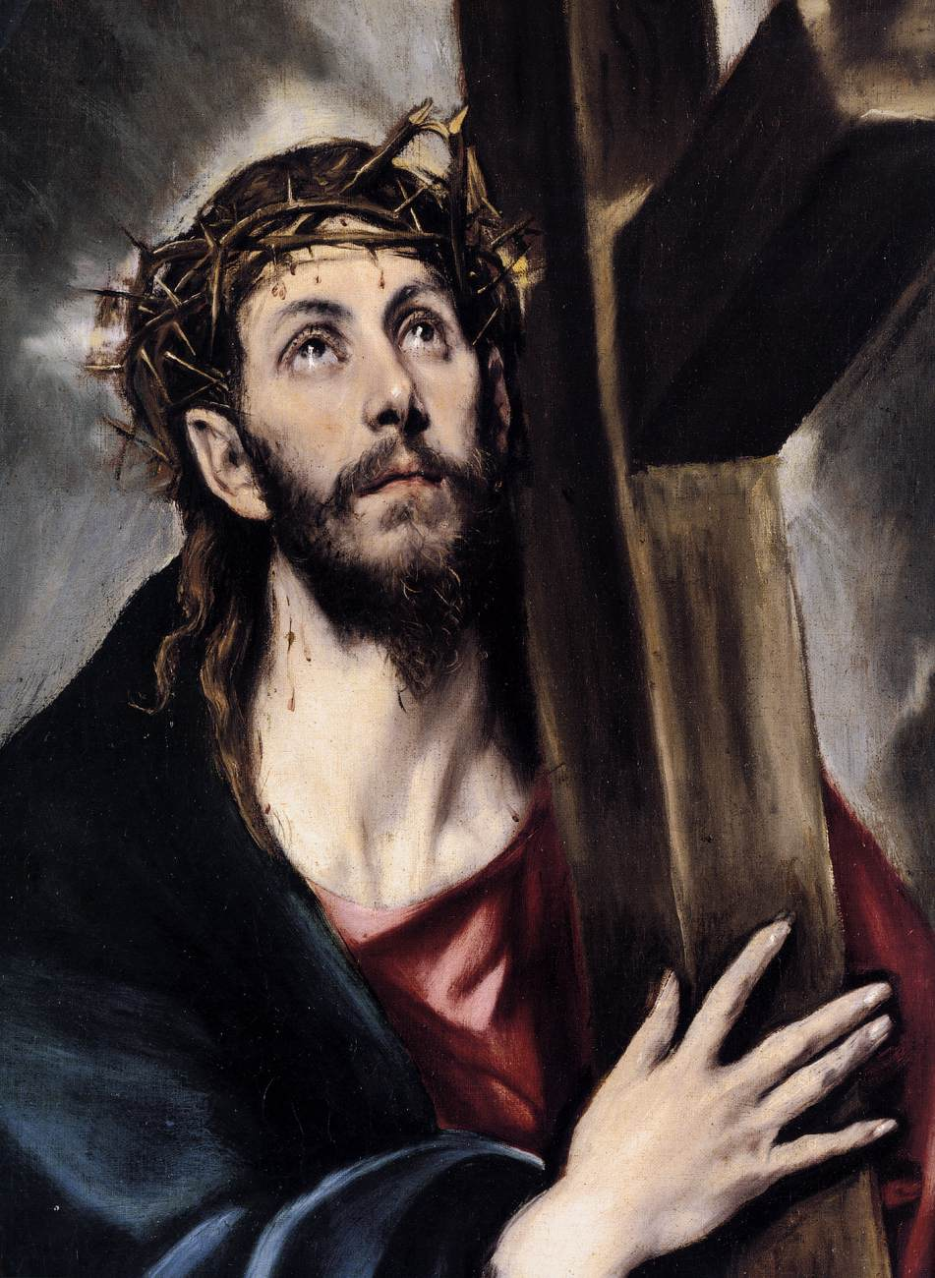

To Christians, one of the most enduring and identifiable symbols of their religion is the crown of thorns. It symbolizes the suffering, torture and the humiliation Jesus suffered before his crucifixion.
However, seeing the portraits of Jesus wearing his crown of thorns has become so commonplace that we do not really think about what it would really mean to wear one.
How humiliating would it be to wear this “crown”? What would it feel like? How much pain would it cause? How long could we endure wearing such a device?
Since developing your sense of empathy is to experience life from someone else’s perspective, an excellent way to do this is to have a crown of thorns ready for your students/attendees to wear. Let them feel the sharp edges. Let them feel the sharp stabbing sensation as they try it on.
Seeing, feeling and wearing the “real thing” is an experience attendees/students will never forget.
Facilitators can find these “crown of thorns” all over the internet. Again, just do an internet search for “crown of thorns” and you should get several hits. Facilitators need to just make sure that they are getting the real thing. There are many plastic and costume crowns out there. That is not what you want. You want the real crown of thorns from the holy land in order to ensure a realistic experience.

