HAIR
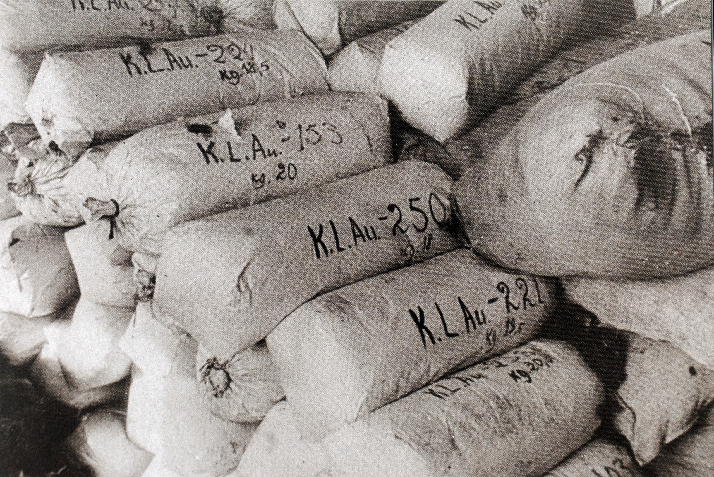
Hair
It is not just any part of our body. It is a part of our body that we can directly control and manipulate to take on our individual personality. With it, we express who we are and how we feel. Without it, we do not even recognize ourselves, nor do the people who know us.
When the Nazis imprisoned their captives, one of the first things they did was shave their prisoners’ heads. Instantly, not only was part of the prisoner’s body amputated, but with it went one of the most recognizable aspects of the prisoner’s identity as a human being.
The Nazis would then package the prisoners’ hair and sell it to make felt.
This pile of hair was placed at your work station. You stare at it. You know where it came from and can only imagine what happened to its owner. Your job at Dachau is to sort through all of this loose hair with your fingers and package it for sale to a German felt factory. In other words, you are helping the Third Reich make a profit.
You look up and see your German guard watching you.

- What do you do? Do you start sorting through this human hair and stuffing it into these packages with your base fingers and hands? What will happen to you if you refuse? What will happen to you mentally if you do it?

- You see a clump hair that is the same shade and length as your mother’s. What goes through your mind?

- What would happen if no one cooperated with the Nazis?

- What strikes you most about this photo?

