**SAMPLE HAZARD PAY SAMPLE POLICY**

Due to the nature of the COVID-19 pandemic, some employees may be needed to perform hazardous duties, work in locations deemed to be potentially hazardous or both. The Company recognizes that employees should be compensated for their willingness to take on potentially hazardous duties during the COVID-19 pandemic.

Hazard duty pay (HDP) is a pay differential the Company might add to an employee’s base pay. Employees may receive HDP while they are performing certain duties for the Company that the Company sees as being potentially hazardous during this pandemic, which might include contact with the public, working in close proximity with others, working in potentially hazardous locations and any other factors deemed pertinent by the Company.

HDP may be paid for all hours the employee is exposed to such hazardous conditions, as defined by the Company.

HDP will not be paid when the employee is not performing duties of a hazardous nature.

HDP will be paid as either a flat rate or as a percentage of the employee’s pay, as determined by the Company.

HDP will not be paid when the employee is on an unpaid leave of absence or on paid leave away from the assigned location.

The ____ will administer this program.

**OSHA: WHO IS MOST AT RISK?**

**Factors to consider in granting “Hazard pay”**

OSHA has divided job tasks into **four risk exposure levels**:

* Very high,
* High,
* Medium, and
* Lower risk.

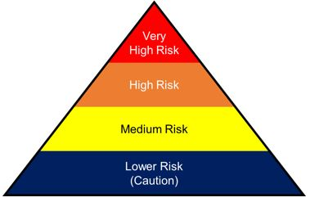

The four exposure risk levels represent the probable distribution of risk. Most American workers will likely fall in the lower exposure risk (caution) or medium exposure risk levels.

###### **Lower Exposure Risk (Caution)**

Jobs that do not require contact with people known to be, or suspected of being, infected with COVID-19. Workers in this category have minimal occupational contact with the public and other coworkers. Examples include:

* Remote workers (i.e., those working from home during the pandemic).
* Office workers who do not have frequent close contact with coworkers, customers, or the public.
* Manufacturing and industrial facility workers who do not have frequent close contact with coworkers, customers, or the public.
* Healthcare workers providing only telemedicine services.
* Long-distance truck drivers.

###### **Medium Exposure Risk**

Jobs that require frequent/close contact with people who may be infected, but who are not known to have or suspected of having COVID-19. Workers in this category include:

* Those who may have frequent contact with travelers who return from international locations with widespread COVID-19 transmission.
* Those who may have contact with the general public (e.g., in schools, high population density work environments, and some high-volume retail settings).

###### **High Exposure Risk**

Jobs with a high potential for exposure to known or suspected sources of COVID-19. Workers in this category include:

* Healthcare delivery and support staff (hospital staff who must enter patients’ rooms) exposed to known or suspected COVID-19 patients.
* Medical transport workers (ambulance vehicle operators) moving known or suspected COVID-19 patients in enclosed vehicles.
* Mortuary workers involved in preparing bodies for burial or cremation of people known to have, or suspected of having, COVID-19 at the time of death.

###### **Very High Exposure Risk**

Jobs with a very high potential for exposure to known or suspected sources of SARS-CoV-2 during specific medical, postmortem, or laboratory procedures. Workers in this category include:

* Healthcare workers (e.g., doctors, nurses, dentists, paramedics, emergency medical technicians) performing aerosol-generating procedures (e.g., intubation, cough induction procedures, bronchoscopies, some dental procedures and exams, or invasive specimen collection) on known or suspected COVID-19 patients.
* Healthcare or laboratory personnel collecting or handling specimens from known or suspected COVID-19 patients (e.g., manipulating cultures from known or suspected COVID-19 patients).
* Morgue workers performing autopsies, which generally involve aerosol-generating procedures, on the bodies of people who are known to have, or are suspected of having, COVID-19 at the time of their death.

###### **Specific Job Duties That Affect Workers’ Exposure Risk Levels**

As workers’ job duties change or they perform different tasks in the course of their duties, they may move from one exposure risk level to another. Additional examples of workers who may have increased risk of exposure to COVID-19 include those in:

* Other types of healthcare positions (including pre-hospital and medical transport workers, allied medical care professionals, and support staff)
* Emergency response (e.g., emergency medical services workers, firefighters, and law enforcement officers)
* Other postmortem care positions (e.g., funeral directors)
* Research or production laboratory workers
* Airline operations
* Retail operations, particularly those in critical and/or high-customer-volume environments
* Border protection and transportation security
* Correctional facility operations
* Solid waste and wastewater management
* Environmental (i.e., janitorial) services
* In-home repair services
* Travel to areas where the virus is spreading
* Pastoral, social, or public health workers in jobs requiring contact with community members who may spread the virus
* Transit and delivery drivers, depending on their degree of close contacts with the public

This list is not intended to be comprehensive, and employers should always rely on thorough hazard assessments to identify if and when their workers are at increased risk of exposure to the virus on the job.

***Scott Warrick, JD, MLHR, CEQC, SHRM-SCP***

***Scott Warrick Human Resource Consulting, Coaching & Training Services***

***Scott Warrick Employment Law Services***

(614) 738-8317 ♣ [scott@scottwarrick.com](mailto:scott@scottwarrick.com)  
[www.scottwarrick.com](http://www.scottwarrick.com) **&**  [www.scottwarrickemploymentlaw.com](http://www.scottwarrickemploymentlaw.com/)

**Link Up With Scott On** [**LinkedIn**](http://www.linkedin.com/in/scottwarrickconsulting)

Scott Warrick, JD, MLHR, CEQC, SHRM-SCP ([www.scottwarrick.com](http://www.scottwarrick.com) & [www.scottwarrickemploymentlaw.com](http://www.scottwarrickemploymentlaw.com/)) is both a practicing Employment Law Attorney and Human Resource Professional with almost 40 years of hands-on experience. Scott uses his unique background to help organizations get where they want to go, which includes coaching and training managers and employees in his own unique, practical, entertaining and humorous style.

**That is why Scott has been described as “The Comedian Trainer.”**

[**Scott Trains Managers & Employees ON-SITE in over 50 topics**](https://scottwarrick.com/training/)… all of which can be customized **FOR YOU!**

***LET SCOTT DESIGN A PROGRAM FOR YOU!***

Scott combines the areas of law and human resources to help organizations in “Solving Employee Problems ***BEFORE*** They Start.” Scott’s goal is ***NOT*** to win lawsuits. Instead, Scott’s goal is to ***PREVENT THEM*** while improving ***EMPLOYEE MORALE***.

Scott’s book, **[“Solve Employee Problems Before They Start:](http://scottsbooksandvideos.com/) *[Resolving Conflict in the Real World”](http://scottsbooksandvideos.com/)*** is #1 for New Releases on Amazon for Conflict Resolution books!

Scott’s “[**Employment Law Videos**](https://scottwarrick.com/products/employment-law-videos/)” on the ADA, FMLA, FLSA and Harassment, [**“The Human Resource Professional’s Complete Guide To Federal Employment And Labor Law”**](https://scottwarrick.com/products/books-and-guides/) **&** Scott’s[**“Do It Yourself HR Department”**](https://scottwarrick.com/products/books-and-guides/)are favorites for anyone wanting to learn Employment Law and run an HR Department.

Scott has been named one of Business First’s 20 People To Know In HR, CEO Magazine’s 2008 Human Resources “Superstar,” a Nationally Certified Emotional Intelligence Instructor and a SHRM National Diversity Conference Presenter in 2003, 2006, 2007, 2008 and 2012.

Scott has also received the Human Resource Association of Central Ohio’s Linda Kerns Award for Outstanding Creativity in the Field of HR Management and the Ohio State Human Resource Council’s David Prize for Creativity in HR Management.

Scott’s academic background and awards include Capital University College of Law (Class Valedictorian (1st out of 233) and Summa Cum Laude), Master of Labor & Human Resources and B.A. in Organizational Communication from The Ohio State University.

[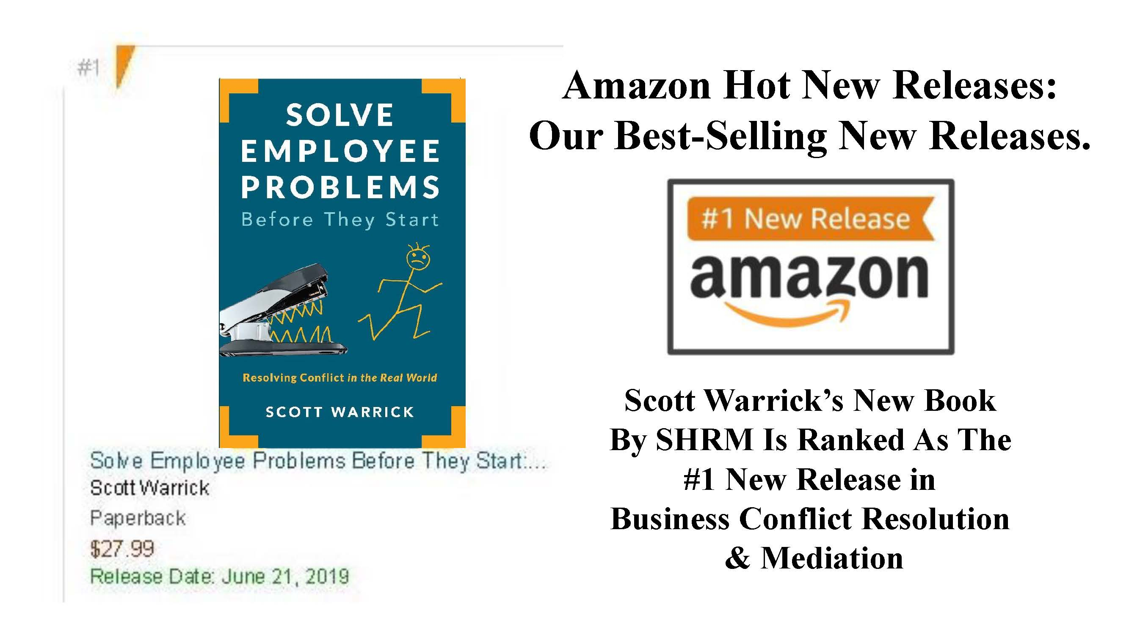](http://scottsbooksandvideos.com/)