RINGS
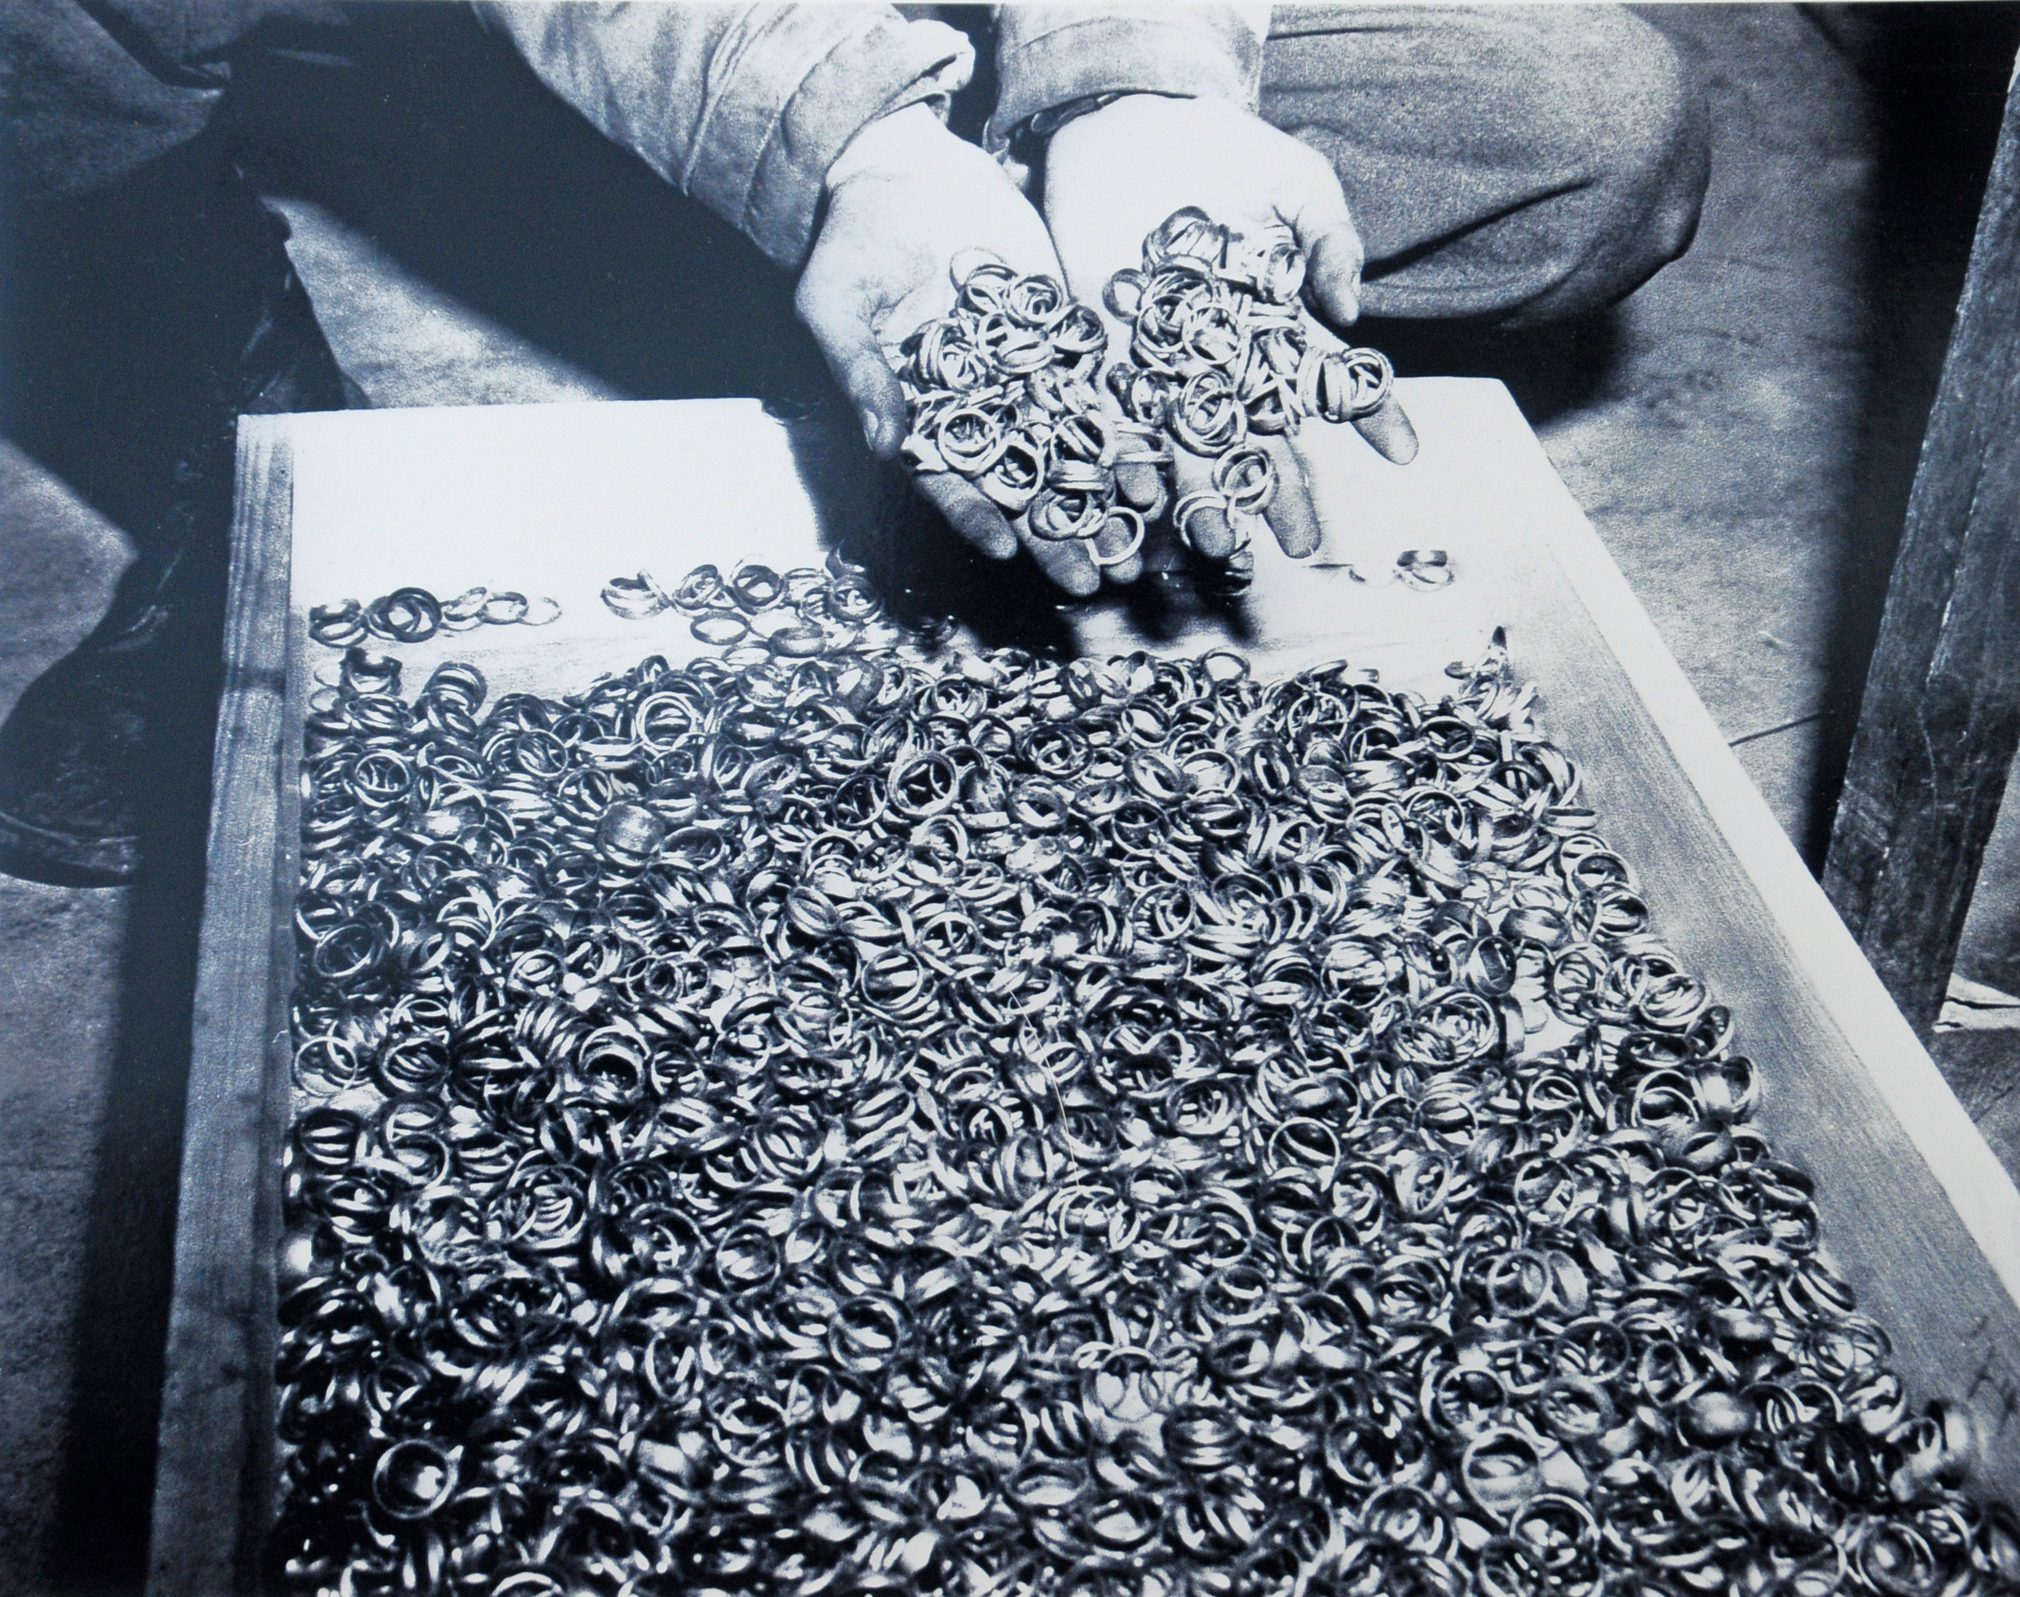
Rings
One of the most prized and honored possessions a human being can possess is often a ring. For centuries, rings have symbolized something sacred that he/she wants to display to the entire world. The meaning of the ring could symbolize an honor bestowed by one’s country, an academic achievement or a long honored family heirloom that symbolizes one’s pride in their heritage.
These rings are the most sacred of all: Wedding rings.
You are a goldsmith who was working in Munich. You were arrested by the Nazis as you came out of a movie one night with your spouse and children. You were sent to Dachau.
Hundreds of gold rings are dumped in front of you as you sit at your work station. Your job is to weigh them, determine their value, then send them on to be melted down into gold bars to profit the Reich.

- How do you think the owner would feel if he/she saw his/her ring in this pile?

- What does this photo tell you about the Nazis?

- You look inside one of these rings. It says, “To Inez 1-15-07.” What does this mean to you?

- What strikes you most about this photo?

