SHOES
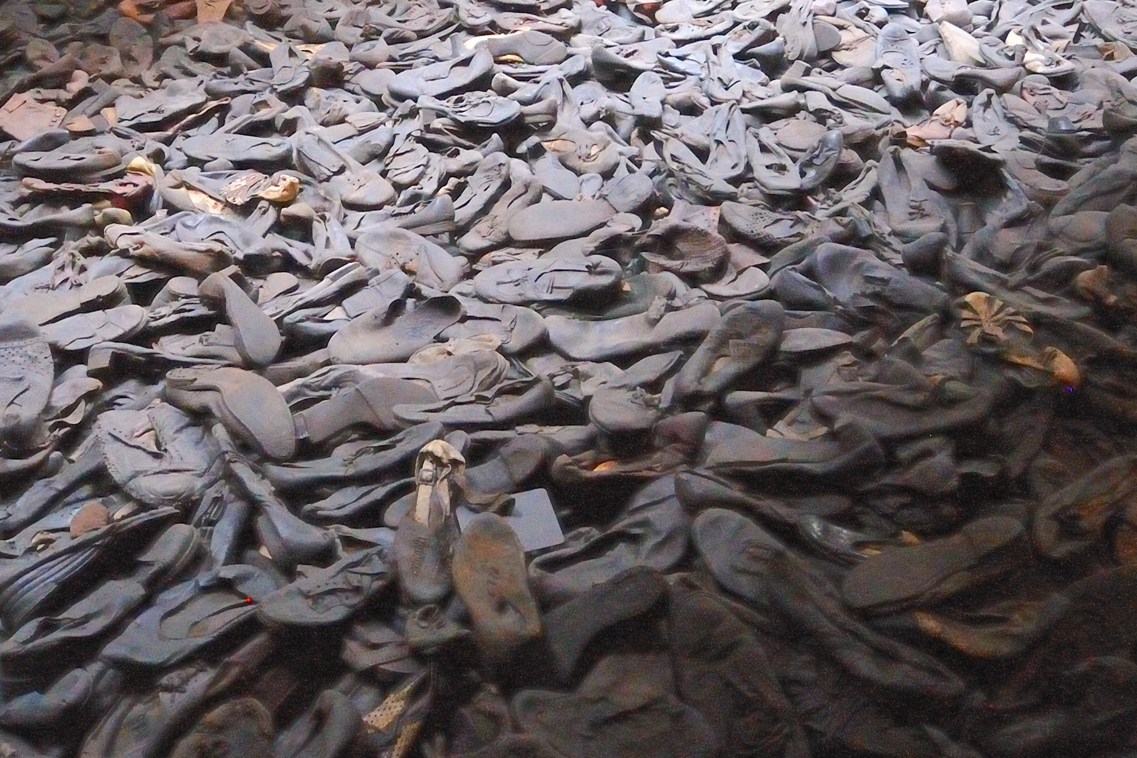
Shoes
They are more than just an item of clothing. They take on the shape of our body. We see ourselves by the imprint we make in them. They reflect who we are and our personality in the styles that we choose. Our shoes reflect, well … us.
However, as you can see in the above photo, these shoes have been discarded as worthless, much like their owners. Thousands of shoes, which yesterday had great value to their owners, are now being treated as if they never had any value at all.
Your job is to place these shoes into a pile and burn them. You pick a couple of them up and see the impressions left behind by its owner. You clearly see where their toes made their mark into the leather soles ... but each one is different.
One shoe is very stylish. It was at one time an expensive shoe for a female. The other is a work shoe for a male.
- What do you suppose these two people were like? How were they similar? How were they different?

- Would you look to see if you recognized any of these shoes?

- Why do these shoes seem to be alive?

- What strikes you most about this photo?

