VISION SIMULATOR CARD
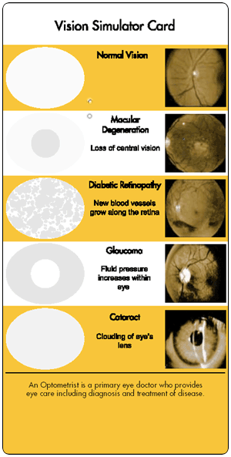
For those of us who are blessed with the gift of sight, it is hard to relate to someone with Macular Degeneration, Diabetic Retinopathy, Glaucoma or Cataracts. However, if we are going to be able to relate to those who do have these conditions, then the “Vision Simulator Card” is just what a facilitator needs.
The “Vision Simulator Card” allows the person using it to look through the eyes of someone with these various conditions. As a result, your students/attendees do not have to guess or imagine what it is like to be afflicted with one of these conditions … they will know.
The “Vision Simulator Card” makes an excellent empathy building exercise to distribute in class. Facilitators can do a simple internet search for “Vision Simulator Card” to get these cards.

